San Diego State Baseball
2015 Halloween Game
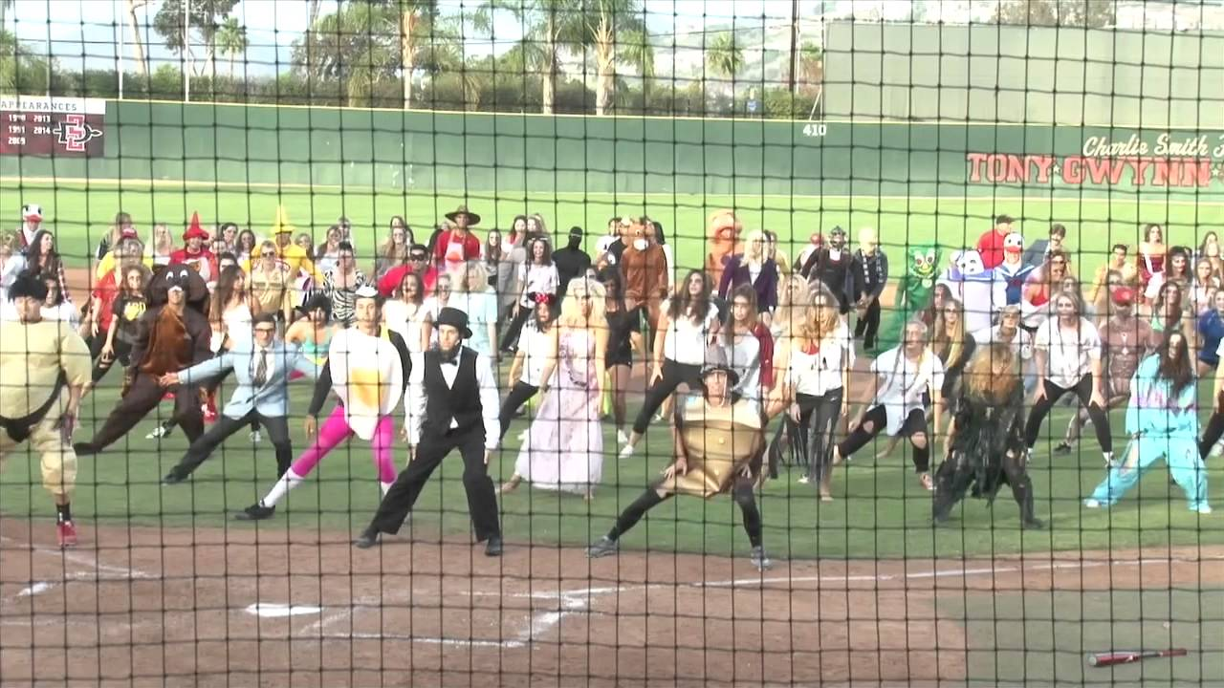
October 31st-12:00pm

Join the Aztecs, DSA, D.A.D.S.
& Best Buddies. Families and friends
(in costume) are welcome!
*Special guest-Champ Pederson
*Admission is free-Gates open-11:30am
*Challenger game prior to main event!

