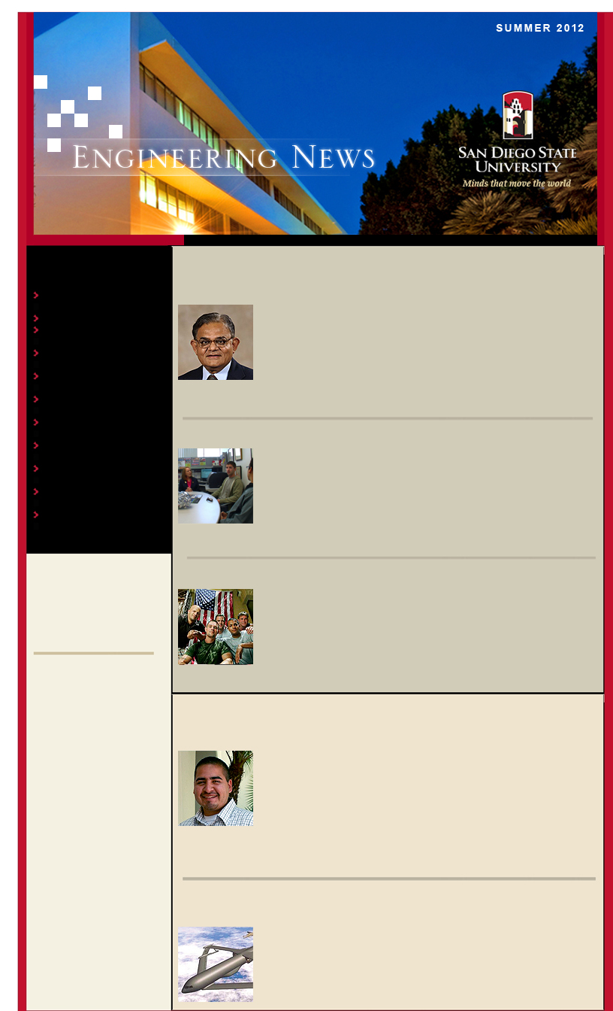
IN THIS ISSUE

Madhu Gupta Selected Microwave Lecturer
Student Design Day
SERVICE program turns Veterans to Engineers
Student Receives NSF Graduate Fellowship
Doctoral Student Receives Awards
Thomas Johnston Favorite Faculty
Explore SDSU Open House Success
SDSU Alumni Lenny Barbod Guest Lectures
Aerospace Engineering creates CITER
Engineering Veterans Success
Gustaaf Jacobs Helps Student Win Science Award

Thomas Johnston Honored as Favorite Faculty

Mechanical Engineering’s Tom Johnston was recently selected one of 25 Favorite Faculty on campus by the Residential Education Office. This award is special because the election is made by the students themselves.

Each year the Residential Education Office asks the students living in the residence halls to nominate their favorite faculty member at SDSU. As a result they collect hundreds of nominations. Faculty members with the highest number of votes are invited to a special Favorite Faculty Award Dinner at the end of the academic year.

Read More

Madhu Gupta Selected Distinguished Microwave Lecturer

Congratulations to Electrical Engineering faculty member, Madhu Gupta, for being selected Distinguished Lecturer by the Institute of Electrical Electronics Engineers (IEEE) and Microwave Theory and Techniques (MTT) society. Each year MTT society selects a group of Distinguished Microwave Lecturers who are recognized as experts in their field.

Read More

SERVICE Program Turns Veterans into Working Engineers

College of Engineering staff member Patricia Reily continues to excel in her engineering SERVICE (Success in Engineering for Recent Veterans through Internship and Career Experience) Program. Her passion to help veteran obtain internships in engineering shows in number. In the 16 months she has worked here, Patricia has networked and found engineering internships for 38 veterans.

Read More

Engineering Veterans Success

The Northrop Grumman Foundation pledged a $100,000 grant to San Diego State University’s Troops to Engineers. The program is called SERVICE – Success in Engineering for Recent Veterans through Internship and Career Experience. “The Troops to Engineers program has the numbers that show that it really works” said Vice President of engineering for Northrop Grumman Aerospace Systems Frank Flores.

Read More

Student Receives NSF Graduate Research Fellowship

Hats off to Aerospace Engineering student Ismael Reveles for earning the NSF Graduate Research Fellowship Award. It is impressive that Ismael’s hard work and talent earned him this prestigious award, but what is even more extraordinary is that Ismael won this Graduate Award as an undergraduate student.

Read More

Doctoral Student Earns Awards at the Research Expo (UCSD)

Congratulations to Aerospace Engineering’s Rauno Cavallaro who recently was awarded the Structural Engineering’s Best Poster and Best Literature Review Awards.

Read More

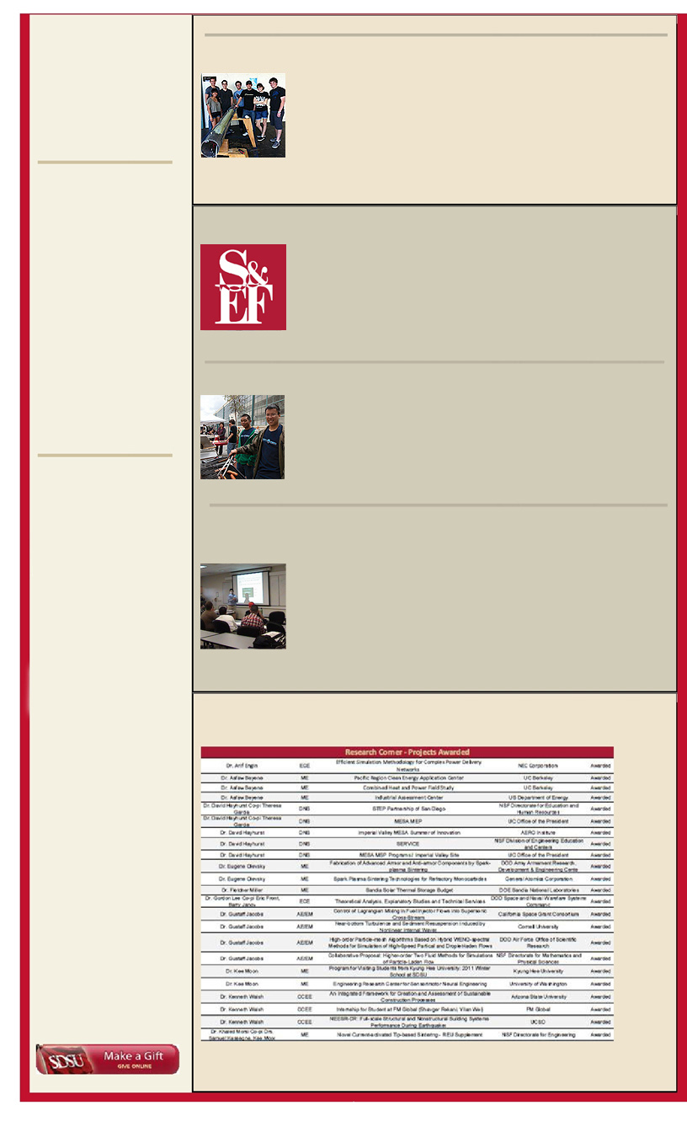
Aerospace Engineering Creates New Collaborations with CITER

The Department of Aerospace Engineering at SDSU achieved an explosive growth within its graduate research program investments in the past five years. Administered by Professor Gustaaf Jacobs, a Center of Industrial Training and Engineering Research (CITER) was created to structure and enhance the interaction between industrial partners and SDSU.

Read More

MESA students expand horizons trainingacademy

The San Diego State University MESA Engineering Program attended the Training Academy at Hamilton Sundstrand on Friday, April 13, 2012. As part of the MESA program collaborative with Southwestern College and San Diego City College, a total of 21 students attended. The event, which took place at Hamilton Sundstrand Power Systems, aimed to expose a group of college level engineering students to Hamilton Sundstrand, business development, and skills needed to succeed in the workplace.

Read More

College of
Engineering
San Diego State University
5500 Campanile Drive, E-
203 San Diego, CA
92182-1326
Ph: (619) 594-6061 Fax: (619) 594-6005
engineering.sdsu.edu

Senior Design Day

The College of Engineering is proud of the many teams and student groups who presented their innovative design projects at the 2012 Senior Design Day. The event took place on May 4th at the Parma Payne Goodall Alumni Center, which opened to the public with invitations sent to local companies, alumni, and others.

Read More

Gustaaf Jacobs Helps Student Win San Diego Science Fair

Dillon Patel, high school student at Crest Canyon Academy in San Diego, has shown prospective talent in Aerospace Engineering. Patel previously participated in a program at his high school called QUEST which encourages students to pursue scientific research on the topic of their interest.

Read More

Explore SDSU Open House Success

San Diego State University's College of Engineering attracted an impressive number of interested students at this year’s Explore SDSU. With the guidance of the College of Engineering’s Donovan Geiger and Larry Hinkle, the day was a success from the start.

Read More

SDSU Alumni Lenny Barbod Guest lectures

San Diego State University Engineering Alumni Lenny Barbod has offered a unique perspective to Dr. Karen May-Newman’s students. Mr. Barbod has been working at Guidant Corporation/Abbott Vascular for 23 years as an engineer specializing in catheter and stent design, which is used in angioplasty techniques.

Read More

Research Proposals

Click here to view the Full List of Submissions and Awards

