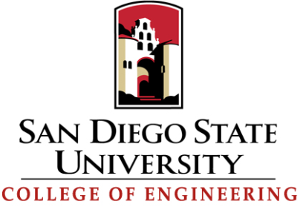

FALL 2012 FACULTY RETREAT
August 21, 2012, 8:30 AM
Extended Studies Building, Room 206/208

8:00 AM Continental Breakfast
8:30 AM Call to Order-Dean Hayhurst
8:45 AM Engineering Entreprenuership, A Georgia Tech Perspective
Keith McGreggor, Director, Venture Labs
10:15 AM Break
10:30 AM High Tech Business Creation, a San Diego Perspective
Duane Roth, CEO CONNECT
11:00 AM Discussion of collaborations with the College of Business Administration and
EMC
11:30 AM Review of College Successes (Staff invited)
- ERC Status, Sam Kassegne
- DOE Sunspot Program, Fletcher Miller
- SERVICE Program, Patricia Reily
12:15 PM Lunch for faculty and staff
1:00 PM State of the College – Dean Hayhurst
1:20 PM College of Engineering Business Meeting
2:00 PM Open Discussion
2:30 PM Adjourn
6:00 PM College Reception and Dinner aboard The Berkeley

