

Center for Sensorimotor Neural Engineering

PRESENTS

“Active RF and mm-Wave MEMS Resonators
Using Transistor Sensing”

Dana Weinstein, PhD
Finn Assistant Professor
Electrical Engineering and Computer Science
Massachusetts Institute of Technology
Dr. Weinstein will discuss the Resonant Body Transistor (RBT), which can be integrated into a standard CMOS process for low power clock generation and high-Q tank circuits. We recently demonstrated the first hybrid RF MEMS-CMOS resonators in Si at the transistor level of IBM’s 32nm SOI CMOS process, without the need for any post-processing or packaging. The unreleased, Si bulk acoustic resonators are driven capacitively using the thin gate dielectric, and actively sensed using a body-contacted nFET incorporated into the resonant cavity. FET sensing with the high f_{T}, high performance transistors in CMOS amplifies the mechanical signal before the presence of parasitics. The resulting RF-MEMS resonators provide low power, low cost, small footprint building blocks for on-chip signal generation and processing.
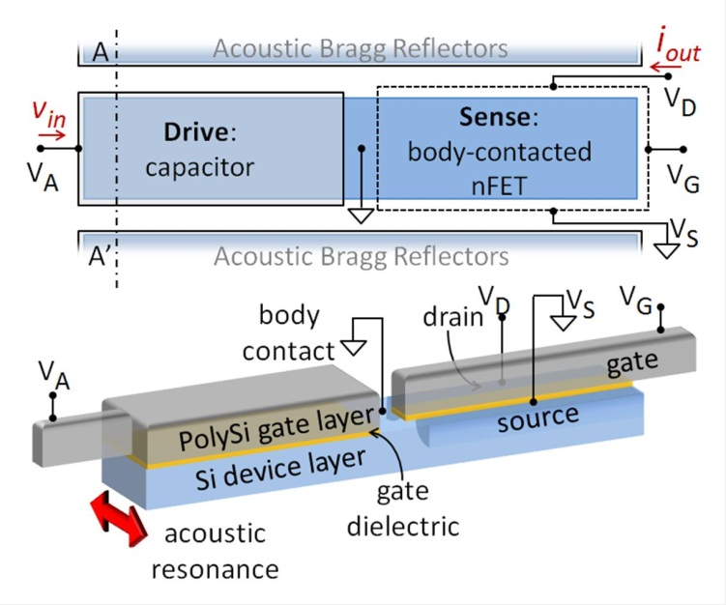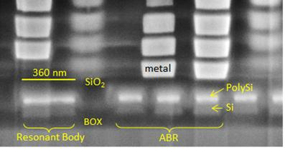

Figure 1. (left) Schematic of CMOS-integrated Resonant Body Transistor (RBT). (right) Cross section of CMOS stack showing RBT in the Si device layer. The device resonates at 11 GHz with no post-processing or packaging of the CMOS chip.
Monday, February 13, 2012
3:30 PM – 4:30 PM
SDSU will connect via videoconference from SDSU, room E203e
Space is limited, please arrive early; contact Theresa Garcia, tgarcia@mail.sdsu.edu for questions

This seminar is supported by the NSF ERC for Sensorimotor Neural Engineering (EEC-1028725).

