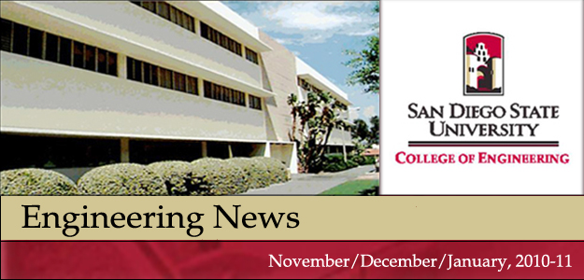
In this edition
♦ Dr. Fletcher Miller Represents SDSU at SolarPACES 2010
Conference
♦ Donovan Geiger Awarded Presidential Staff Excellence Award
♦ Cubic Corporation Makes $100,000 Gift to the College
♦ Dr. Luciano Demasi Earns Best Paper Award
♦ Dr. Joe Katz Publishes Text on Introductory Fluid Mechanics
♦ Stig Johansson Received AIAA Award
♦ Associate Dean German Travels the Globe
♦ Tracking the Dean - Highlights of the Dean's Calendar
♦ Research Corner - Projects Submitted & Awards Granted
Reminders
Wed. Feb. 9 at 10 am is the next ALL-Staff Meeting in the Dean’s Conference Room.
Thurs. Feb. 10 at 11 am is the next ALL-faculty Meeting, location is still TBD.

Dr. Fletcher Miller Represents SDSU at SolarPACES 2010 Conference
Mechanical Engineering’s Dr. Fletcher Miller and graduate student Kyle Kitzmiller were invited to travel to Perpignan, France in September to the SolarPACES 2010 conference, to present their research on the thermodynamics of solar-coupled gas turbines. They are working on powering a jet engine using the heat of the sun.
SDSU was well-represented at the conference. Steve Ruther, a Mechanical Engineering graduate and current JDP student, also submitted a paper that was accepted at the conference. He was unable to attend, but his work was presented in poster form. Dr. Miller was co-author on an additional paper. Although there were many U.S. companies present, SDSU and Cornell University were the only two U.S. schools to attend the conference. Read More

Donovan Geiger Recieves Presidential Staff Excellence Award
Donovan Geiger, Coordinator in the Engineering Student Affairs Office, was awarded the prestigious Presidential Staff Excellence Award, in the category of Service to the Community, by President Weber at the Staff Awards ceremony in October. This is the second year for the Presidential Staff Excellence Awards, which are designed to recognize exceptional contributions by university staff.
Donovan’s deep commitment to community service and volunteerism were recognized by this award. He is presently the elected Vice President of the Tierrasanta Community Council, representing over 35,000 residents to local, state, and federal officials. He is also the Vice Chair of the non-profit Tierrasanta Planning Group which evaluates commercial development, infrastructure improvements, and code-compliance issues in the community. Read More

Cubic Corporation Makes $100,000 Gift to the College
The College of Engineering is pleased to announce a gift of $100,000 from the Cubic Corporation to the Communication Systems and Signal Processing Institute, directed by Dr. Madhu Gupta, Professor of Electrical and Computer Engineering and RF Communications Systems Industry Chair. Cubic has been a primary and critical supporter of the Institute since 1996. “We are pleased by Cubic's continued support of the Communications Systems and Signal Processing Institute's activities. This gift will continue to fund graduate student and faculty research in areas important to the local technical community as well as the overall national economy and security,” said Dr. Gupta. Read More

Dr. Luciano Demasi Earns Best Paper Award
Congratulations to Aerospace Engineering’s’ Dr. Luciano Demasi who recently was awarded Best Paper Published in 2008 by the International Editorial Board of the Journal of Composite Structures. The award is given annually to the paper judged by the journal’s editorial board to have made the most significant contribution to composite structures in a particular year.
Dr. Demasi’s paper, “∞³ Hierarchy plate theories for thick and thin composite plates: The generalized unified formulation” was published in July 2008 in the Journal of Composite Structures and focuses on a general model that unifies the available theories for composite structures. Read More

Dr. Joe Katz Publishes Text on Introductory Fluid Mechanics
Dr. Joe Katz Professor of Aerospace Engineering has authored a textbook entitled Introductory Fluid Mechanics, that was published in August 2010 by the Cambridge University Press.
The textbook familiarizes students with the basic elements of fluid mechanics so they will know the terminology of the discipline and the expected results. The text also serves as a long-term reference for students who go on to study the subject in greater depth.
The textbook is different than others on fluid mechanics because it is shorter and has been simplified so it’s more logical and easier for students to understand. Dr. Katz originally started teaching Introductory Fluid Mechanics about five years ago because he knew it was course students often struggled with. “I tried to make it easier to learn and also to teach,” said Dr. Katz. Read More

Stig Johansson Received AIAA Award
Stig Johnasson, retired Aerospace Engineering technician, has received the Outstanding Contribution to Aerospace Education Award from the San Diego section of AIAA.
The award is given annually to any individual or company that makes a significant contribution to the advancement of aerospace education. SDSU faculty members have received this award in the past, but Mr. Johansson is the first technician to receive it.
Johansson attended the AIAA awards banquet in May. There he met with some past students who are now on of the AIAA nomination committee. During his time at SDSU, Johansson worked with students on their senior projects as they researched and built aerodynamic models and tested them in the lab’s wind tunnels. Read More

Associate Dean German Travels the Globe
Dr. Rand German, Associate Dean, says he’s “travelled out.“ That’s because in 2010 he travelled extensively, in some months averaging a trip a week! He receives invitations from all corners of the world to speak and to consult – often many more than he could possibly accommodate. In the Spring 2010 semester he represented SDSU in Egypt on an NSF grant to collaborate on a project in Cairo, was awarded Honorary Membership in the Korean Powder Metallurgy Institute in Korea, and had a Chinese company pay for him to travel to and give a seminar in China. During the Fall semester he travelled to Florence, Italy to give a talk at an International Congress, to South Africa to lecture on sintering and witness sintering of diamond, and to the Galapagos Islands in Ecuador for a personal vacation. Read More

Tracking the Dean - Highlights of the Dean's Calendar
Date | Event
1/24 | Dean Hayhurst will meet with Irwin Zhan and Dean’s Advisory Board Members
1/24 | Dean Hayhurst will have lunch with CSU Trustee Carol Chandler
1/25 | Dean Hayhurst will attend a meeting on developing SDSU’s Congressional Strategy
1/26 | Dean Hayhurst will meet with Barbara Abelin, Vice President of Human Relation at Cubic Corporation
1/26 | Dean Hayhurst will participate in the CONNECT Board meeting
1/27 | Dean Hayhurst will have breakfast with President Weber and Bob Slapin, Executive Director of San Diego Software Council
2/2 | Dean Hayhurst will have lunch with CSU Trustee Debra Farar
2/4 | Dean Hayhurst attend the CSU Engineering Dean’s Meeting at Cal State San Jose
2/11 | Dean Hayhurst will address the departing Korean Students
2/22 | Dean Hayhurst will have lunch with CSU Trustee Lou Monville

Research Corner - Projects Submitted & Awards Granted

Click Here For Sizable Chart
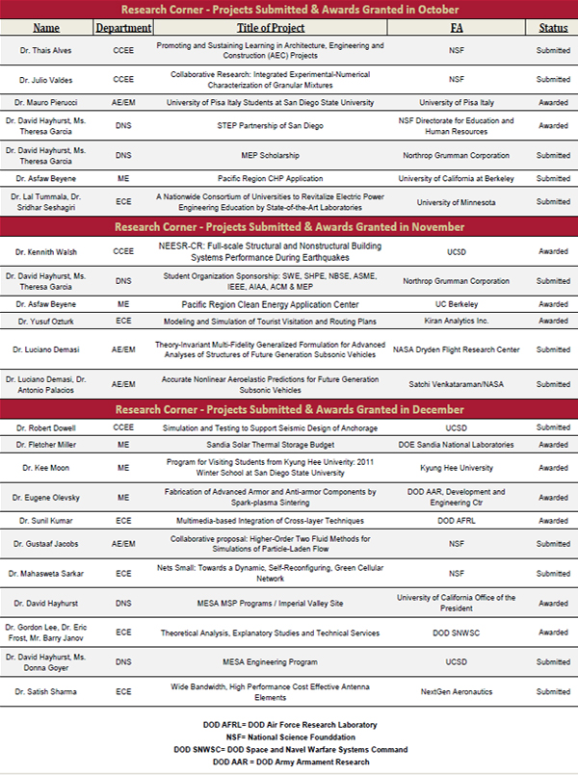

Click Here For Sizable Chart

Thanks to Kaitlin Andrews, Dean's Office Student Assistant and Public Relation major, and to Tyler Salata, Dean's Office Student Assistant and Management Information Systems major for their interviewing, writing and publication contributions to this newsletter.
Please contact Cindi McClain at cmcclain@mail.sdsu.edu or 4-6062 if you have a story or story idea to suggest for future editions.
DISCLAIMER: This new HTML format has not been tested on a wide variety of browsers and mail-servers. Please let Cindi know if you experience any technical difficulties viewing this newsletter so problems can be corrected for the next edition.

