**NASA Marshall Space Flight Center**

**Academic Partnering Workshop**

**Speaker Biographies**

**and Contact Information**

Tuesday, February 22nd

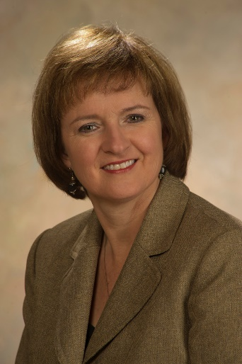

**Whitney Young**

Academia and International Partnerships Manager

Partnerships & Formulation Office

Marshall Space Flight Center

[whitney.young@nasa.gov](mailto:whitney.young@nasa.gov)

256-424-5851

_____________________________________________________________________________________

Whitney Young is the Manager for Academia and International Partnerships in the Partnership and Formulation Office at Marshall Space Flight Center in Huntsville, Ala.

From 2005-2010, Ms. Young was the Environmental Impact Testing Range Lead at the MSFC Impact Testing Facility (ITF) in the Environmental Effects Branch initiating formal agreements with Department of Defense, Private Industry, and Academia.

From 1999 to 2002, Ms. Young operated numerous combined environmental effects equipment for the Space and Environmental Effects Branch.

Ms. Young began her career at Marshall Space Flight Center in 1989 as a Physics Technician in the Materials and Processes laboratory. She earned her Bachelor of Sciences Degree in Mathematics from Athens State University in 1996.

From 1985 to 1989, Ms. Young worked for the Tennessee Valley Authority (TVA) at Browns Ferry Nuclear Power Plant as a radiological chemical analyst. 1985 she earned her Associate’s Degree in General Education from Calhoun Community College.

She has received numerous NASA awards, including a Rotary Stellar Award for MSFC Impact Test Facility Development Team. Ms. Young and her husband Greg reside in Rogersville, Alabama.

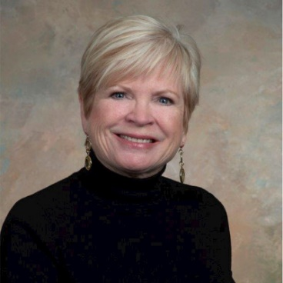

**Dr. Susan Currie**

University Stakeholder Outreach Specialist

Office of Strategic Analysis & Communications

Marshall Space Flight Center

[susan.currie@nasa.gov](mailto:susan.currie@nasa.gov)

256-529-1824

_____________________________________________________________________________________

Dr. Susan Currie is the University Stakeholder Outreach Specialist at NASA’s Marshall Space Flight Center (MSFC) Office of Communications. Located in Huntsville, Alabama, MSFC is home to the Space Launch System rocket and proven technical expertise in propulsion, space systems, science, and technology.

Dr. Currie is a retired educator who taught middle school, served as a middle school administrator, and directed the Office of Special Education Services for Madison County Schools in Huntsville, AL. She has been employed by NASA as a contractor and then civil servant since 2009.

While at MSFC, Dr. Currie has served as project manager for NASA’s STEM Educator Professional Development Collaborative, coordinating delivery of various forms of professional learning experiences for pre-service, in-service, informal and higher education educators. Additionally, she led recruiting efforts for MSFC and supported the NASA Pathways Internship Program.

Currently, Dr. Currie works to develop relationships with higher education institutional leadership in support of NASA missions and MSFC programs/projects. Working closely with MSFC’s Partnership Office, Dr. Currie looks for opportunities to create partnerships between MSFC and educational institutions based on current and future capabilities in support of NASA missions.

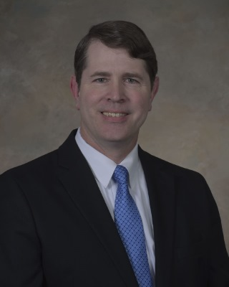**Dr. David Burns**

Manager

Science and Technology Office

Marshall Space Flight Center

[david.m.burns@nasa.gov](mailto:david.m.burns@nasa.gov)

_____________________________________________________________________________________

Dr. David Burns is manager of the Science and Technology Office at NASA’s Marshall Space Flight Center in Huntsville, Alabama.

Named to the position in January 2017, he leads the organization that plans, develops, and executes a broad range of science and technology investigations, programs, projects, and activities in support of NASA’s science, technology, and exploration goals. The office also leads the pursuit of new opportunities and partnerships with industry and other government agencies.

In 2020, Burns took an assignment at NASA Headquarters as the acting deputy associate administrator for Exploration in the Science Mission Directorate. He managed the Lunar Discovery and Exploration Program and the Commercial Lunar Payload Services initiatives.

His NASA career began in April 2016, when he was named deputy of the Space Systems Department of Marshall’s Engineering Directorate. Prior to joining NASA, Burns was director of Science and Technology at the U.S. Department of Defense Missile Defense Agency.

From 2006 to 2008, he was chief executive officer of Dielectric Blue Inc, of Huntsville, a company he founded that specializes in the design and manufacturing of anti-tamper sensors for military and commercial applications. From 2003 to 2006, he was a manager at Science Applications International Corp., of Huntsville, and assisted in the development of the Armed Robotic Vehicle-Heavy.

Burns retired from the U.S. Air Force in 2003 after 20 years of active duty service.

He holds a doctorate in electrical engineering from the Air Force Institute of Technology in Ohio; a master’s degree in electrical engineering from the University of Dayton in Ohio; and a bachelor’s degree in electrical engineering from the U.S. Air Force Academy in Colorado. His awards include the Office of the Secretary of Defense Medal for Exceptional Civilian Service.

Burns and his wife, Cheryl, have four children and reside in Huntsville.

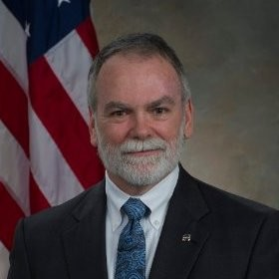**L. Dale Thomas, Ph.D., P.E.**

Deputy Director, Propulsion Research Center

University of Alabama in Huntsville

Director of Alabama Space Grant Consortium

_____________________________________________________________________________________

Dale Thomas currently serves as a Professor and Eminent Scholar of Systems Engineering in the Department of Industrial and Systems Engineering and Engineering Management at the University of Alabama in Huntsville (UAH). He teaches system engineering students in the art and science of systems architecture and design, systems integration, test, and verification, and systems management. Dale also serves as director of the Alabama Space Grant Consortium and as deputy director of the UAH Propulsion Research Center.

Prior to his retirement from NASA in July 2015, Dale served as the Associate Center Director (Technical) for the NASA Marshall Space Flight Center (MSFC) in Huntsville, Alabama, providing technical leadership for all MSFC spaceflight projects. He had previously served as the Program Manager of the NASA Constellation Program Office at Johnson Space Center in Houston, Texas, leading a nationwide team including all NASA field centers and five prime contractors.

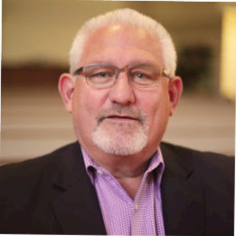**Mark J. Gradkowski**

Senior Vice President

KeyLogic Associates

Board Chair Tennessee Valley Corridor

_____________________________________________________________________________________

Mark is an experienced Executive with over 40 years of professional experience. He currently serves as the Senior Vice President of KeyLogic Associates.

He previously served as the Executive Vice President and Chief Administrative Office of the Downtown Rescue Mission. He was an Executive with Teledyne Brown Engineering, Teledyne Energy Systems and Teledyne Turbine Engines in various capacities ranging from Profit and Loss responsibilities to strategic planning, business development and acquisitions for 18 years. In this capacity, Mark was responsible for multiple business units with annual revenue of over $100M.

He has demonstrated growth and results through his business acumen and leadership. Prior to joining Teledyne, Mark was Vice President of operations for MDM Services and Tetra Tech Inc.

He currently serves as the Board Chair of the Tennessee Valley Corridor (TVC).

He also serves as a KTECH Ambassador, a workforce initiative of Kids to Love.

He has a BS from Indiana State University and Executive Leadership, Leadership/Management from The Jessie H. Jones Graduate School of Management at Rice University.

**Hugh (Trey) Cate**

Deputy Manager, SLS Strategic Communication

Space Launch System

Marshall Space Flight Center

[hugh.c.cateiii@nasa.gov](mailto:hugh.c.cateiii@nasa.gov)

_____________________________________________________________________________________

Hugh C. Cate III (Trey) graduated from West Point in 1987 as a Lieutenant of Artillery and retired from the military 21 years later as a Senior Public Affairs Officer. During his service as a Public Affairs Officer, he served in, Germany, Bosnia, Kosovo, Iraq, Afghanistan, and various other locales working at every level of Military Command while leading organizations of as little as 7 people to over 200.

Trey currently serves as the Deputy Manager for Strategic Communication for NASA’s Space Launch System. In that role he coordinates all external and internal communication, messages, stakeholder engagements, congressional engagements, and products for America’s next great ship. Trey has a Mechanical Engineering Degree from West Point, a Master of Journalism from the University of Alabama and an Aerospace and Defense Masters of Business Administration from the University of Tennessee.

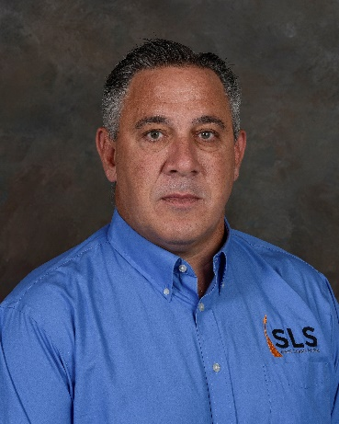**Jeramie Broadway**

Senior Technical Assistant

Office of Associate Director, Technical

Marshall Space Flight Center

[jeramie.w.broadway@nasa.gov](mailto:jeramie.w.broadway@nasa.gov)

_____________________________________________________________________________________

Mr. Jeramie Broadway currently serves as the Senior Technical Assistant to the Marshall Space Flight Center Associate Director, Technical. His main duty is to support the development, coordination, and implementation of MSFC strategic planning and partnering within NASA and across industry and academia. He was previously the Assistant Manager of the Partnerships and Formulation Office, providing strategic planning and business development support as well as creating partnering and new mission opportunities for the center.

Jeramie has been with Marshall Space Flight Center since 2008, where he began his career in the Materials and Processes Laboratory supporting and leading production operations for both the Ares I and SLS launch vehicles. Jeramie has been the Project Engineer or Deputy Project Manager of numerous projects over the years including the Nuclear Cryogenic Propulsion Stage Project where he served as the Nuclear Fuel Material Development Lead, working to develop advanced high temperature materials for nuclear fuels. Jeramie has also served as the Assistant Chief Engineer for Launch Vehicles supporting NASA’s Commercial Crew Program.

Jeramie holds a Master of Science degree in Aerospace Engineering from the University of Alabama and a Bachelor of Science degree in Mechanical Engineering from the University of North Dakota. Jeramie is a Veteran of the United States Air Force, originally from Dallas, TX. Jeramie is married to Sherrie Beal Broadway with 4 children, Kaylen, Ellie, Carsen, and Nolan.

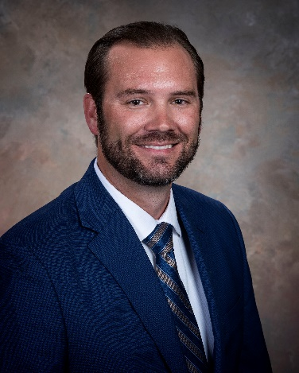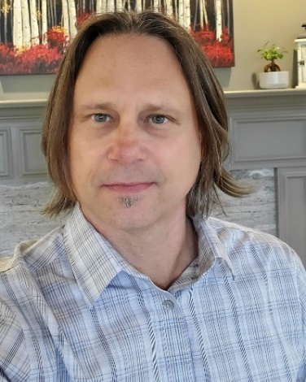**Robert Hickman**

Exploration Formulator

Partnerships & Formulation Office

Marshall Space Flight Center

[robert.r.hickman@nasa.gov](mailto:robert.r.hickman@nasa.gov)

256-544-8578

_____________________________________________________________________________________

Robert R. Hickman is a Senior Engineer and Technical Lead at the NASA Marshall Space Flight Center. He has a Bachelor of Science degree in Materials Science and Engineering from the University of Alabama at Birmingham (1997) and over 20 years of experience in the design, development, and testing of aerospace hardware. He currently serves as the Exploration Formulation Manager in the Partnerships and Formulation Office (PFO). Responsibilities include business development, technology development and project formulation for Habitation, Advanced ECLSS, Landing Systems, and Lunar Surface Integration.

Prior to his role in PFO, Mr Hickman spent 4 years as the Advanced Manufacturing Subsystem Manager and Production Lead for the NASA Space Launch System (SLS) Liquid Engines Office. His responsibilities include technical management of the RS-25 Engine Block IV Product Improvement Project for the development of advanced manufacturing techniques. Mr. Hickman also served as the Production Lead Engineer for the SLS Liquid Engines Office responsible for manufacturing, assembly, testing, and certification of integrated flight engine deliverables. Mr. Hickman spent 13 years in the NASA Materials and Processes Laboratory as a Project Engineer, Principle Investigator, and Assistant Branch Chief for the development of state-of-the-art metallic components for space vehicle structures, power, propulsion, and other exploration systems. Project Engineering roles included the Production Lead for the Ares I Upper Stage Common Bulkhead Project. He served as the Principle Investigator on numerous advanced materials and process technology programs including large Scale Additive Manufacturing for Lightweight Structures, On-Orbit Servicing Assembly and Manufacturing (OSAM), Advanced In-Space Chemical Propulsion, Nuclear Thermal Propulsion and Power, and High Temperature Propulsion Components.

**Zenia Garcia**

Propulsion & Transportation Formulator

Partnerships & Formulation Office

Marshall Space Flight Center

[zenia.a.garcia@nasa.gov](mailto:zenia.a.garcia@nasa.gov)

256-544-4751

_____________________________________________________________________________________

Zenia Alejandra García is currently supporting the Partnerships and Formulation Office at NASA Marshall Space Flight Center as the Propulsion & Space Transportation System’s formulation manager.

Mrs. García is From EL Paso, Texas and a graduate of The University of Texas at El Paso, where she obtained a Bachelor’s Degree in Mechanical Engineering in 2010 and a Master’s in Mechanical Engineering in 2012. Her NASA career started as an Intern in 2008 and 2009 at the NASA Marshall Space Flight Center, and then continued as a Graduate Co-op between 2010 and 2012. During this time, she supported multiple organizations including, EV32 Structural and Mechanical Design Branch, ER33-Valves, Actuators & Ducts, Design & Development Branch, and EM10 Materials Testing Branch, Tribology Team.

In her professional career, Mrs. García has Supported SLS Block 1 Multi-Purpose Crew Vehicle Stage Adapter (MSA) efforts in various capacities, mainly in design and manufacturing. In her previous role, Mrs. Garcia supported SLS Block 1B as the Payload Adapter Design Lead, where she was responsible for leading flight hardware primary structure design, and ensuring hardware meet all operational requirements. In her latest role Mrs. Garcia, is responsible for the development of, and serve as the focal point for orchestrating the execution of the center strategy for propulsion & space transportation systems, as well as for identifying and recommending adjustments to center strategy that enable the formulation of new markets.

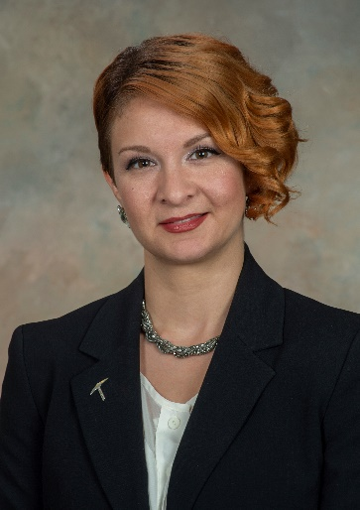

**Dr. John Carr**

Advanced Technologies Formulator

Partnerships & Formulation Office

Marshall Space Flight Center

[john.a.carr@nasa.gov](mailto:john.a.carr@nasa.gov)

256-544-7114

_____________________________________________________________________________________

Dr. John Carr is MSFC’s Advanced Propulsion and Technology Systems Formulator as well as the P.I. for the LISA-T (Lightweight Integrated Solar Array and anTenna) flight program. After completing undergraduate work, Dr. Carr began his career in private industry at the semiconductor manufacturer, Micron Technology, Inc. Dr. Carr then furthered his education through graduate work at Iowa State University and joined NASA in 2012 as a power system engineer. He quickly became involved with technology development and began leading thin-film array development in 2014. In 2019, Dr. Carr joined Office of the Chief Technologist and served as MSFC’s deputy Chief Technologist until mid-2021, when he rotated to his current formulator role in MSFC’s Partnerships and Formulation Office.



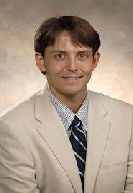**Justin Jackson**

Advanced Manufacturing Formulator

Partnerships & Formulation Office

Marshall Space Flight Center

[justin.r.jackson@nasa.gov](mailto:justin.r.jackson@nasa.gov)

256-961-2215

_____________________________________________________________________________________

Justin Jackson received a Bachelor of Science and Master of Science degree in Mechanical Engineering from Mississippi State University.  He has worked as a materials engineer at NASA for over 15 years, working on a variety of space flight programs including the Space Transportation System, Constellation, and most recently Artemis Program.  He has also been heavily involved in several technology focused activities including the Composite Cryotank Technologies Development and the Rapid Analysis and Manufacturing Propulsion Technology project.  Justin is currently the Advanced Manufacturing Formulation Manger at the Marshall Space Flight Center.

**Scott Tashakkor, P.E.**

Flight Software Development Team Lead

AI/ML Digital Transformation Representative

Marshall Space Flight Center

[scott.b.tashakkor@nasa.gov](mailto:scott.b.tashakkor@nasa.gov)

256-961-1173

_____________________________________________________________________________________

Scott Tashakkor, P.E. is MSFCs AI/ML Digital Transformation Representative. Mr. Tashakkor has written and tested flight and ground software and is currently MSFC’s team lead for flight software. Mr. Tashakkor is serving as the lead for NASA NESC’s Software Tech Fellow’s Software Architecture Review Board (SARB). He has been working on software development, simulations, testing, and AI/ML his whole career. He has a master’s degree in Aerospace Engineering specializing in Computational Fluid Dynamics (CFD) and Numerical methods, and a master’s degree in Computer Engineering specializing in Parallel and High-Performance Computing. His P.E. license is in Thermal and Fluid Systems. He volunteers for open-source software development outside of work.

**Nicole Pelfrey**

Deputy Chief

Science Research and Projects Division

Marshall Space Flight Center

[nicole.w.pelfrey@nasa.gov](mailto:nicole.w.pelfrey@nasa.gov)

_____________________________________________________________________________________  
  
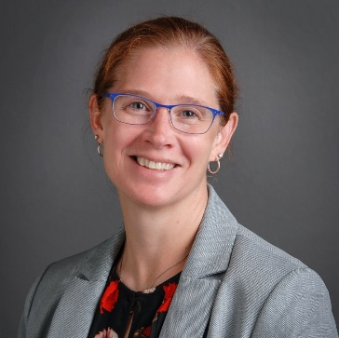Nicole graduated from the South Carolina Governor’s School for Science and Math in Hartsville, SC in 1994 and received a Bachelor of Science degree in biology from Wofford College in 1998. She began her career in the generic pharmaceutical industry, starting as a compliance auditor, leading a microbiology lab and performing research and development for new products. She spent 8 years performing microbiological and chemical testing of drug products.  She also served as the assistant quality control laboratory manager for the seventh largest generic pharmaceutical company in the United States.  In 2006, She joined the International Space Station (ISS) Payload Operations Team as a Payloads Communications Manager (PAYCOM), collaborating with the ISS crew to ensure successful on-board science operations. She served as PAYCOM team lead for 6 years before shifting her focus to training and organizational management. She served as the operations engineer for an ISS emerging technology development project, supported multiple technical contract proposal teams, developed training for multiple organizations, and supported the Sierra Nevada Dream Chaser vehicle PDR. Her last two years on the ISS Program were as the Operations Manager for the Mission Operations & Integration contract with ~300 contractors, 10 direct reports across 5 branches and 24 disciplines. In this role she helped to provide efficient resource management through the execution of assigned budget, workforce, and schedule. She also served as the Project Manager for the ISS payload, Earth Knowledge Acquired by Middle School students (EarthKAM), leading execution of the earth science payload which included national and international scientists and students and a partnership with the U.S. Space and Rocket Center and the University of Alabama Huntsville (UAH). In addition, she led the agency’s FY2016 NASA Small Business Mentor Protégé Agreement of the Year, the first ever with a minority serving institution. During this time, she also completed Project Management Training from UAH. Nicole joined NASA in 2018 as the Deputy Manager of the Astrophysics Branch and served as the Branch Manager from May 2019 – June 2021. She was selected as the Deputy Manager, Science Research and Projects Division in June 2021.

Nicole was born and raised in Greenville / Simpsonville, SC. She grew up on a farm with big gardens and lots of animals. Nicole is married to Joseph Pelfrey, with one daughter, Adelyn Reece Pelfrey.

**Joseph Casas**

Small Missions and Department of Defense Formulator

Partnerships & Formulation Office

Marshall Space Flight Center

[joseph.casas@nasa.gov](mailto:joseph.casas@nasa.gov)

256-961-3029

_____________________________________________________________________________________

Joe is currently the Science, Technology & Exploration Small Missions and DoD Formulation Manager within the Partnerships & Formulation Office at NASA MSFC where he has responsibilities for collaborative pre formulation activities supporting future small spacecraft missions and joint DoD collaborative S&T projects. In addition, he serves as the MSFC representative to the Agency level Small Spacecraft Coordination Group (SSCG) and the SMD Rideshare Working Group as well as on the DoD Rideshare Committee. Joe also serves as Project Manager for the joint geospatial NASA DoD Project Arctic Collaborative Environment project sponsored by the Office of the Secretary of Defense under the Joint Capabilities Technology Demonstration Program as well as serves as the Principle Applications Technologist for the joint NASA, Brazil, and the DoD Scintillation Prediction Observations Research Task (SPORT) small spacecraft space weather project sponsored by several US Combatant Commands. Joe has spent over 35 years contributing in academia, business, legislative, gov’t service and organizations associated with the use of space related to both national and international R&T and commercialization activities. These include the only Agency Program Industrialist position supporting the NASA Microgravity Research Program comprised of over 700 research and technology activities with more than 500 emerging technologies in the Program portfolio. He has served in multiple key scientific, engineering and management leadership roles while also engaged in over 24 free flyer and human rated successful space flight experiments including many first of a kind missions. Joe is a past published research scientist, university professor, Chairman Aerospace Advisor to the Virginia Governor, a founding member of the Virginia Space Grant Consortium, co-founding member of the Virginia Space Flight Authority and Vice Chairman of the Board of Directors, Special Advisor to the White House, member of the NASA Advisory Council, successful aerospace entrepreneur and Army veteran.

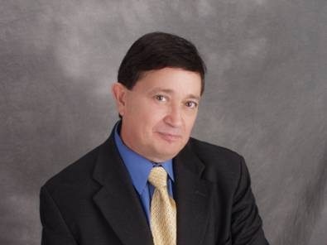

**Reggie Alexander**

Manager

Partnerships & Formulation Office

Marshall Space Flight Center

[reginald.a.alexander@nasa.gov](mailto:reginald.a.alexander@nasa.gov)

256-544-9289

_____________________________________________________________________________________  
  
Reginald Alexander is the Manager Partnerships and Formulation Office at the Marshall Space Flight Center, providing Strategic Planning and Business Development Support as well as creating partnering and new mission opportunities for the center. He was previously of the domain lead for space transportation. In that role he led the development of propulsion technology development and integration planning for future NASA missions.

Previous Jobs

* Strategic Planning and Business Development, Propulsion
* Manager of the Advanced Concepts Office, Engineering Directorate
* Chief Engineer for the Lunar Precursor Robotics Program.
* Lead systems engineer the Space Launch Initiative’s Crew Transfer Vehicle.
* NASA Headquarters as the center’s liaison for thermal protection systems supporting the agency’s return to flight efforts.

Mr. Alexander holds a bachelor’s degree in mechanical engineering from Mississippi State University, and earned a master’s of science degree in aerospace engineering (Heat Transfer/Fluid Mechanics), from the University of Alabama in Huntsville. Mr. Alexander joined NASA January 1990.

