**The SDSU Computational Science Research Center and**

**the SDSU Department of Aerospace Engineering**

**jointly present**

**How to Prevent Direct and Indirect SARS-CoV-2 Airborne Transmission**

*by*

**Prof. Christian J. Kähler**

Institute for Fluid Mechanics and Aerodynamics, Bundeswehr University Munich, Germany [christian.kaehler@unibw.de](mailto:christian.kaehler@unibw.de)

<http://www.unibw.de/lrt7-en>

<https://www.youtube.com/channel/UCY-i8Gh3EQ6jG4Lht5_w-DQ/videos>

Time: Friday, August 27, 2021, 11:00 am – 12:00 noon Pacific Time (US and Canada)

Join Zoom Meeting: <https://SDSU.zoom.us/j/84643100904>

Meeting ID: 846 4310 0904

**[Abstract]** The SARS-CoV-2 pandemic is currently presenting humanity with major challenges. Containing the spread of the virus requires enormous financial, technical and social efforts, and it is impossible to predict how well humanity will cope with the problem. Since the infectious disease not only has an acute course, but can also cause long-lasting systemic damage to infected individuals, prevention of infection is most important. It is generally accepted that the transmission of viruses is largely via droplets and aerosol particles. Therefore, the question of how these aerosol particles are generated and released and how they spread through the room and cause infection is particularly important to answer. Next, there is the question of how to best protect against infection. The answer to this question depends on the areas for which protection is to be established, because different protective measures have to be taken in a pedestrian zone than in buses and trains or in offices, schools and restaurants. To address these two problems, the first part of the talk will present the formation of aerosol particles in the body, their ejection by breathing, speaking, singing and coughing, and their dispersion in space. In the second part, the effectiveness of different protective measures is analyzed experimentally using laser-based measurement data. In particular, the effectiveness of different masks for individual protection, as well as the usefulness of room air cleaners and protective walls, is demonstrated quantitatively. A deeper understanding of the spread processes and the protection options is imperative to effectively limit the spread of the pandemic and thus the costs for the state, the economy and society. Whether society is finally ready to protect itself effectively depends on the insight of the population, but also on the way the measures are implemented politically. This will also be discussed during the lecture, because this pandemic can only be contained if science, technology, politics and the population pull together.

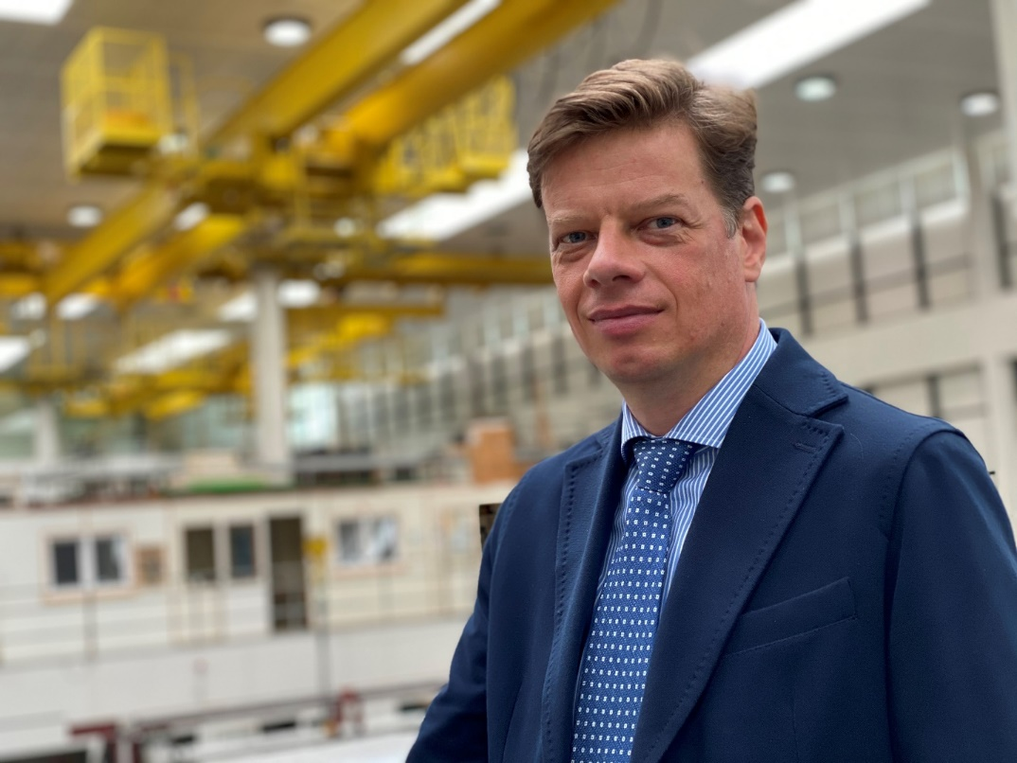

**[Biography]** **Christian J. Kähler** received his Physics Diploma Degree from the Technical University Clausthal in 1997, his PhD in Physics from the Georg August University of Goettingen in 2004 and his Habilitation from the Technical University in Brunswick in 2008. From 1996 to 2001 Dr. Kähler worked at the German Aerospace Center (DLR) in Goettingen, during which he had research stays at the University of Illinois at Urbana Champaign in 1996 and at Caltech in 1998. From 2001 to 2008 he was the head of the research group on Flow Control and Measuring Techniques at the Technical University Brunswick. He then became Professor for Fluid Dynamics and was appointed director of the Institute of Fluid Mechanics and Aerodynamics of the University at der Bundeswehr Munich in 2008. In 2012, he was offered an Einstein professorship for Aerodynamics at the Technical University Berlin (declined) and in 2017 the Technical University Darmstadt offered him to become head of the chair of Fluid Mechanics (declined). 2021, he has received the Rohde Prize, endowed with 10000 euros, for his groundbreaking research work.

His research covers a broad range of topics involving the development of optical measurement techniques on the micro and macro scale in order to further investigate complex phenomenon in microfluidics and turbulent flows at subsonic, transonic, and supersonic conditions. In recent months, his research on SARS-CoV-2 infection has generated a great deal of national and international media attention, and Prof. Kähler has become a much sought-after advisor to policy makers. He is an associate editor of Experiments in Fluids (Springer Nature), an editorial advisory board member of Flow, Turbulence and Combustion (Springer Nature) and editorial board member of Theoretical & Applied Mechanics Letters (Elsevier). He was chairman of the International Conference on Experimental Fluid Mechanics 2018 and organizer of the International Symposium on Particle Image Velocimetry in 2019. He has given many keynote and named lectures and more than 100 invited lectures. He has authored / co-authored over 100 archival publications and 200 conference papers. Furthermore, he co-authored the 3rd edition of the Springer book on Particle Image Velocimetry, which has been cited nearly 8000 times.