**How to Add Students from Waitlist**

After the fifth day of classes, students will not be automatically enrolled if a student drops. Only faculty or department coordinators with access will be able to authorize adds using the WaitList, see timeline below. Below are step by step instructions detailing how to manually add a student from the wait list on WebPortal. Note: 9/5/19 is the last day you can drop students.  If you add them in and they are missing the prerequisites you will need to work with your department and/or the registrar to subsequently drop those that have not met pre-reqs for your course.

[**SDSU WaitList Website**](http://arweb.sdsu.edu/es/waitlist/faculty-staff/index.html)

**Ranking Criteria**

The Wait List ranking is calculated based on completion of prerequisites for the course, a student’s units earned, and if the student already is enrolled in a section for that class. The Wait List ranking is subject to change at any time throughout the registration and schedule adjustment period.

**Registration Timelines**

**Fall 2019**

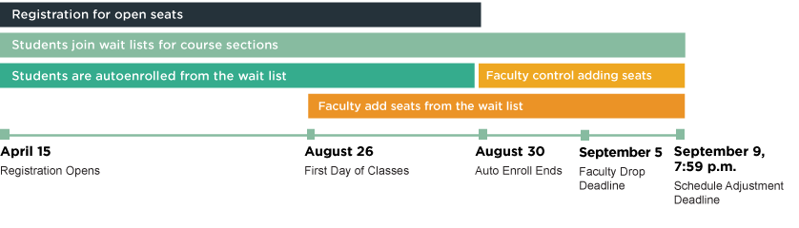

* **April 15**: Registration Opens
* **April 15–August 30**: Registration for open seats
* **April 15–September 9**: Students join wait lists for course sections
* **April 15–August 30**: Students are autoenrolled from the wait list
* **August 26**: First Day of Classes
* **August 26–September 9**: Faculty add seats from the wait list
* **August 30**: Auto Enroll Ends
* **August 30–September 9**: Faculty control adding seats
* **September 5**: Faculty Drop Deadline
* **September 9, 7:59 p.m.**: Schedule Adjustment Deadline

1. Log into your WebPortal and click on WebRoster

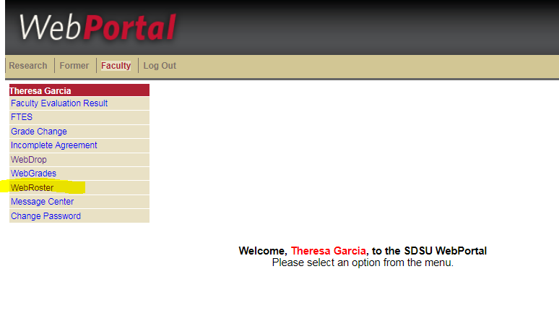

1. See which class have students on the waitlist. Click on that class.

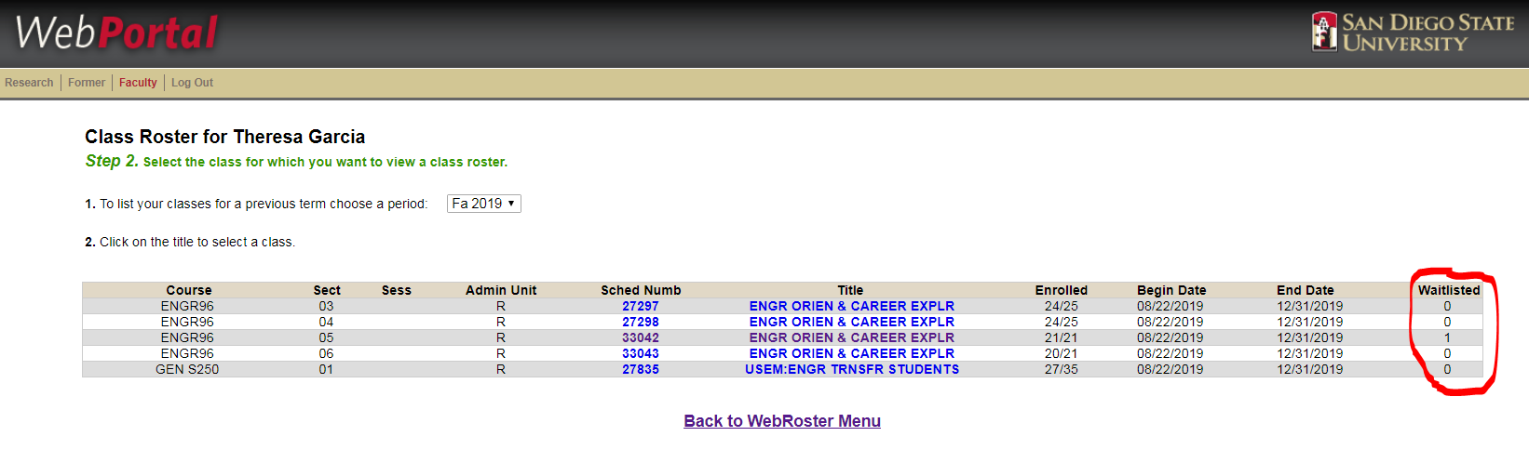

1. See the number of student(s) on your waitlist; click on appropriate link to add students to class.

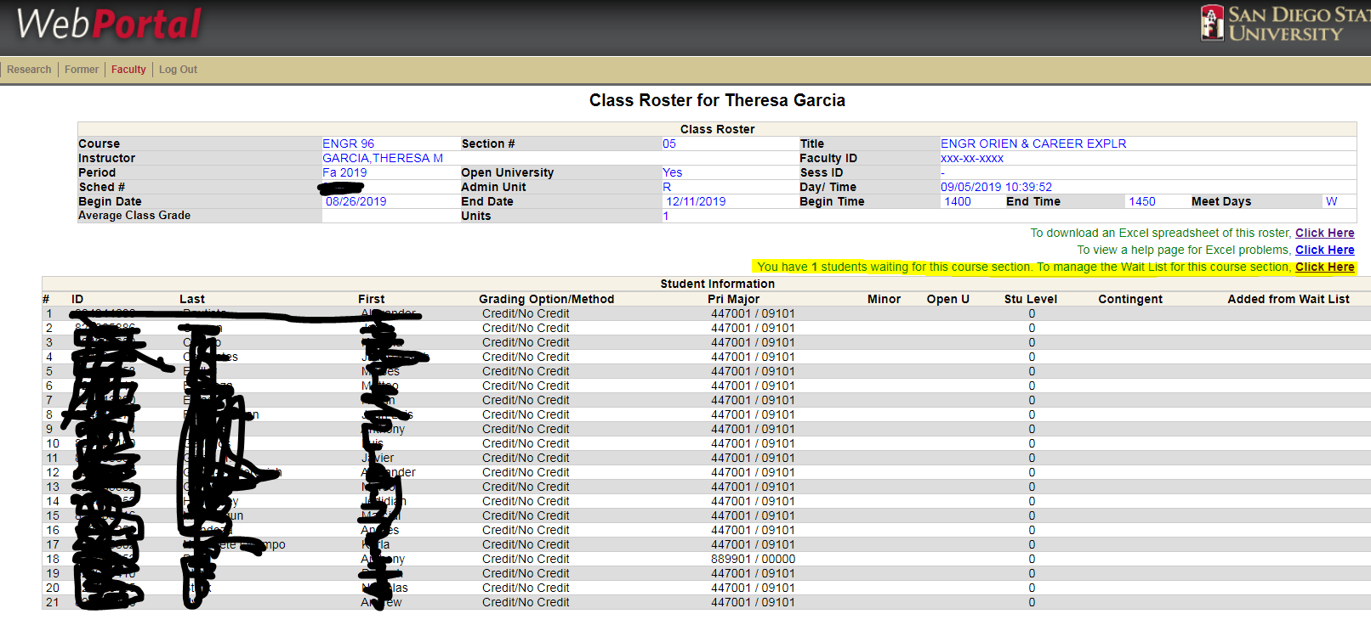

1. Select the appropriate number and click ‘Add students’

