# California Faculty Association

# 2017 Legislation Suggestions

## Submissions Deadline: Friday, November 10, 2017

The CFA Political Action/Legislative Committee encourages CFA members to propose legislation they would like CFA to consider carrying in 2017. If you have a legislative bill idea, complete the form below (with attachments, if needed) and return it to the PA/Leg Committee via CFA Headquarters, 1110 K Street, Sacramento CA 95814; fax (916) 441-3513; or email to [mguerrero@calfac.org](mailto:mguerrero@calfac.org) by ***Friday, November 10, 2017***.

If you have any questions, you may contact committee chair Lillian Taiz at [ltaiz@calfac.org](mailto:ltaiz@calfac.org) or Legislative Director Mario Guerrero at mguerrero@calfac.org or by phone at (916) 441-4848.

CONTACT INFO:

**Name:** Mark Dunster **Email:** mdunster@mail.sdsu.edu

**Chapter/Campus:** SDSU **Phone:** 619-594-5968

**Co-signers**:

*IN DETAIL, DESCRIBE THE PROPOSED LEGISLATION (Use more paper if needed):*

Legislation that mandates a fixed percentage (ideally, the early-90's percentage, 53%) of the total CSU budget must be spent on instruction (non-administrative). It will be necessary to unambiguously define what areas fall under "instruction", so that no administrative or other bureaucratic spending is allowed to be classified as such. 53% cannot be achieved in one year, for obvious reasons. Therefore in the bill the percentage mandated to go to instruction would increase by a fixed and realistic amount annually, until a floor of 53% is reached. A possible figure is an increase of 3% per year, with an exact value to be determined.

The significance of such a proposal is that:  
  
(a) It's simple, and attractive to legislators, voters, students, parents etc. (i.e. virtually everyone except the Chancellor's office and higher administrators.)  
  
(b) It commits no fixed dollars to CSU from Sacramento, and hence would be politically attractive.  
  
(c) Once passed into law, the Chancellor would finally be forced to fight for more CSU dollars, because he would no longer be able to raid the instructional budget to fund Golden Shore Drive and other expensive misplaced non-instructional priorities.

*EXPLAIN WHY THIS LEGISLATION IS NEEDED:*

Since the late 1980s the number of faculty in many departments has roughly halved, while the number of administrators has exploded. As a result, there are fewer classes, and the number of students in many lower division classes has tripled or even quadrupled. Students are being short-changed.  
  
Between 1975 and 2008, the total number of administrators at CSU grew from 3,800 to 12,183 — a 221 percent increase. Things have become even worse since then.  
  
CSU management claim the state has cut spending to the system, but they dishonestly neglect to mention that the CSU budget actually grew by a third between 2004 and 2014 (due to sky rocketing student tuition and fees). During that time spending on managers and supervisors went up by 48 percent, compared to only 25 percent for faculty.  
  
The number of managers and supervisors system-wide grew by about 19 percent during that time, while the number of tenure-track faculty fell by 3 percent.

In 2002 a similar bill was proposed by Sen. Romero (SB 1450) At that time the justification was as follows: "*Dedicating 50% of the CSU Budget to Instruction. The  
CSU instructional budget has declined dramatically over the last 10 years  
from 53.4% in 1990-91 to 41% in 2000-2001. The percentage of the CSU budget  
dedicated to faculty compensation has deteriorated even further. This bill  
requires that 50% of the CSU budget be spent on instructional programs*."

Recent CFA data show that the amount spent on instruction is now about 34%. This is primarily due to an explosion of administration. The result is a disaster for students and the overall education mission of CSU. If SB 1450 had passed the CSU would be completely different now, with students having smaller classes and probably at least 50% more faculty to teach them. With such a bill in place, CFA would also be able to negotiate higher salaries to hire and retain quality faculty and lecturers. In addition, with more T/TT faculty and lecturers (and also higher paid) CFA would have considerably more funding (more union members), and as a consequence significantly more bargaining power.

*WHAT DOCUMENTATION CAN YOU PROVIDE IN SUPPORT OF YOUR PROPOSAL?:*

The California State University system has hired new managers at more than double the rate of other employees over the past decade, according to a recent state audit: <https://www.bsa.ca.gov/pdfs/reports/2016-122.pdf>

The CFA "Race to the bottom" papers from 2015 show the massive decline of faculty (and corresponding increase in administration) over the last decade. In particular the papers at <http://tinyurl.com/y7xla9q6> and <http://tinyurl.com/y8p9ywjh>

Page 4 of the first link is particularly interesting: for example, from 2004 to 2014 the number of tenured/tenure-track faculty here at SDSU has decreased 11%, compared to a 31% increase in SDSU management. Page 8 shows that the average management salary has gone up twice as much as the average FTE faculty at SDSU. Multiply the increase in management with the increase in their salaries and one sees an exponential increase in spending on bureaucracy. And this is just at our campus.

Students, and taxpayers, should be outraged how the CSU management is wasting their hard-earned money.

As mentioned above, currently only about 34% of the overall CSU budget is spent on faculty. **This is the root of all the budget problems at CSU over the last 2 or more decades**. (See the CFA graph below).

In short, we desperately need legislative intervention. In particular, a bill that would require at a minimum 53% of the CSU budget goes to instruction would not cost taxpayers, or students, a dime, and would go a long way to repair the massive damage done by unconstrained administrative spending over the decades

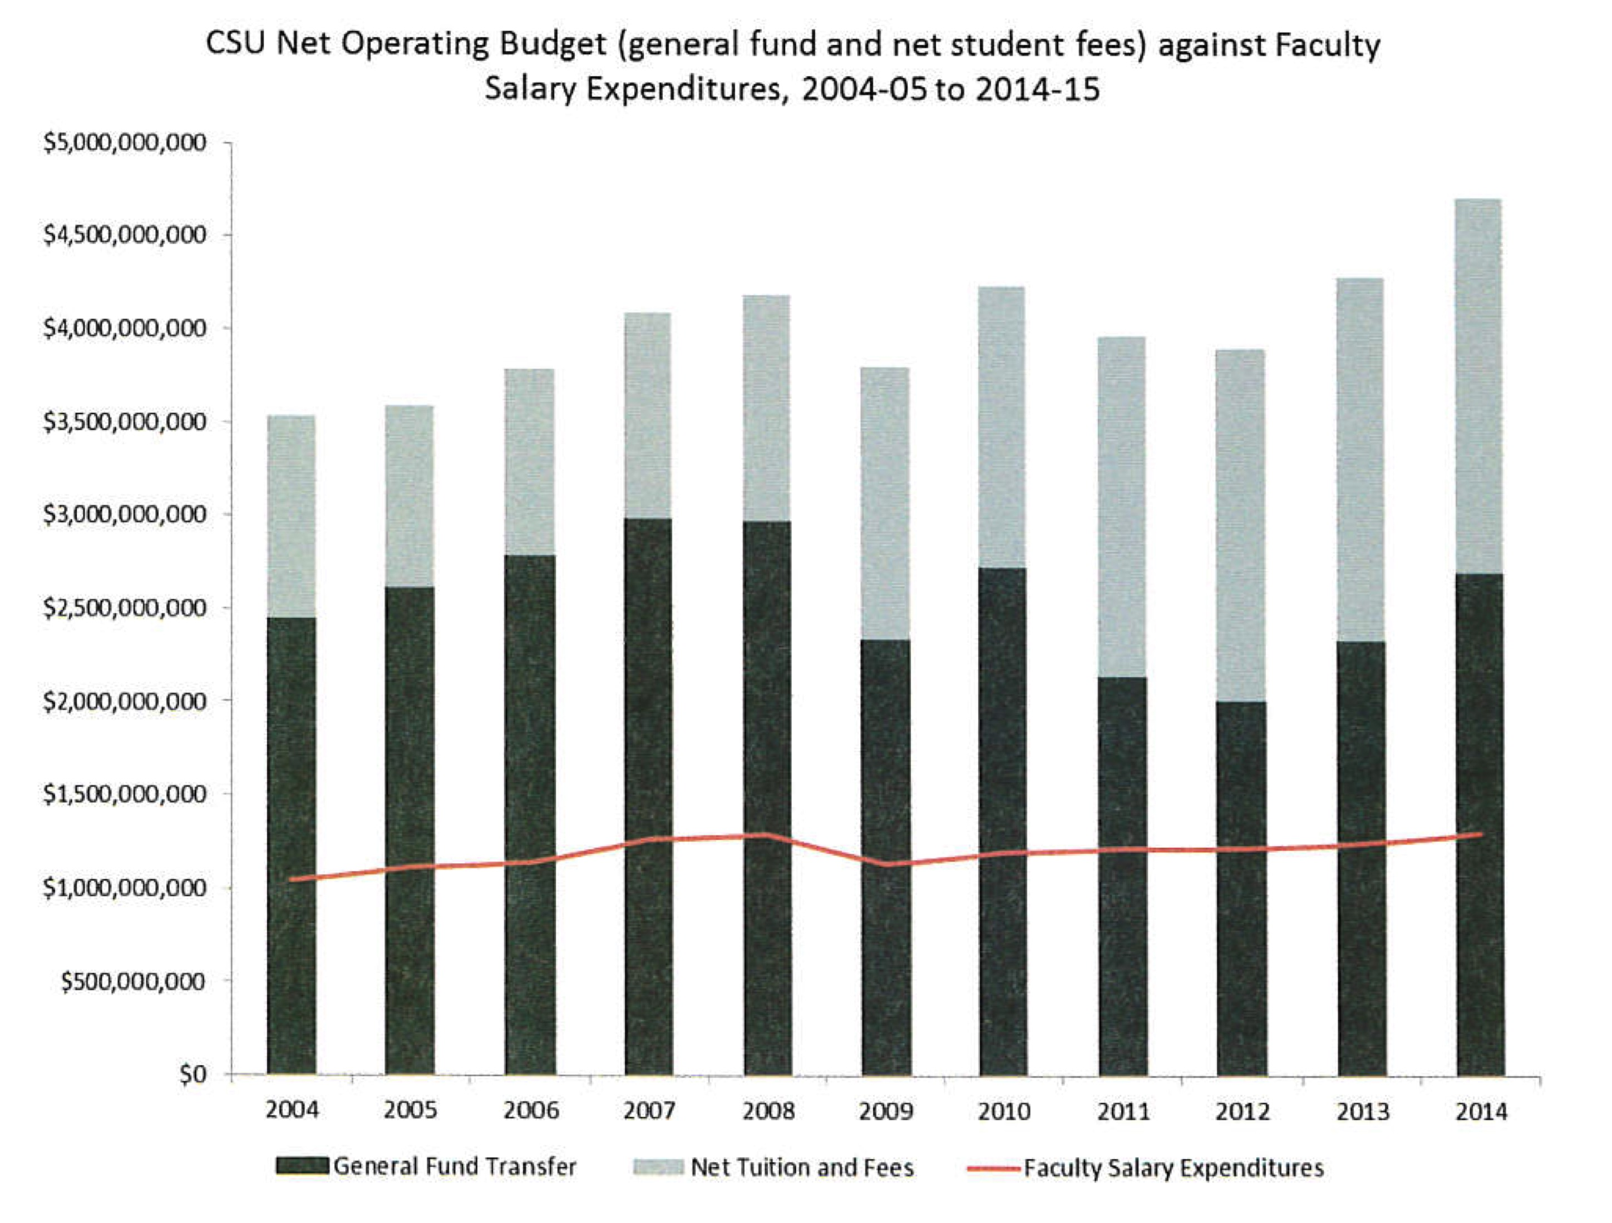

*WHY SHOULD CFA PURSUE A LEGISLATIVE RATHER THAN BARGAINING ROUTE?:*

The legislative route *will* succeed, whereas unfortunately bargaining alone cannot achieve the desired goal; as shown over the last thirty years the CSU administration would never accept such a proposal unless mandated by law, and indeed move in the opposite direction. There are significant differences now as compared to in 2002 when a similar bill by Sen. Romero (SB 1450) was not successful in passing. Firstly, the amount spent on instruction at that time was 41%, and there may have been doubts about the urgency of such legislation then. Now that the figure has decreased to about 34% no such doubts can exist. Secondly, the recent state audit has exposed, and widely publicized, the misplaced CSU administrative priorities. Thirdly, student fees and tuition are at an all-time high, and many students are struggling to graduate. Fourthly, and most importantly, we now have a Democratic supermajority in Sacramento, which greatly increases the chances of passage.

*WOULD YOU BE WILLING TO HELP DRAFT THE LEGISLATION?* (You are not expected to be an expert in drafting legislation.) Yes (Mark Dunster)