**San Diego State Baseball**

**2015 Halloween Game**

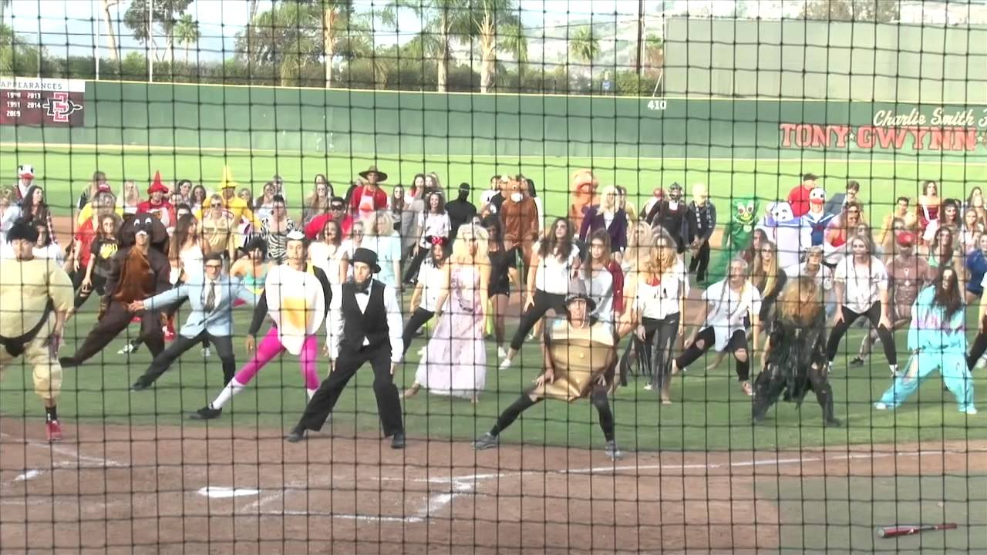**October 31st-12:00pm**

**Join the Aztecs, DSA, D.A.D.S.**

**& Best Buddies. Families and friends**

**(in costume) are welcome!**

**\*Special guest-Champ Pederson**

**\*Admission is free-Gates open-11:30am**

**\*Challenger game prior to main event!**