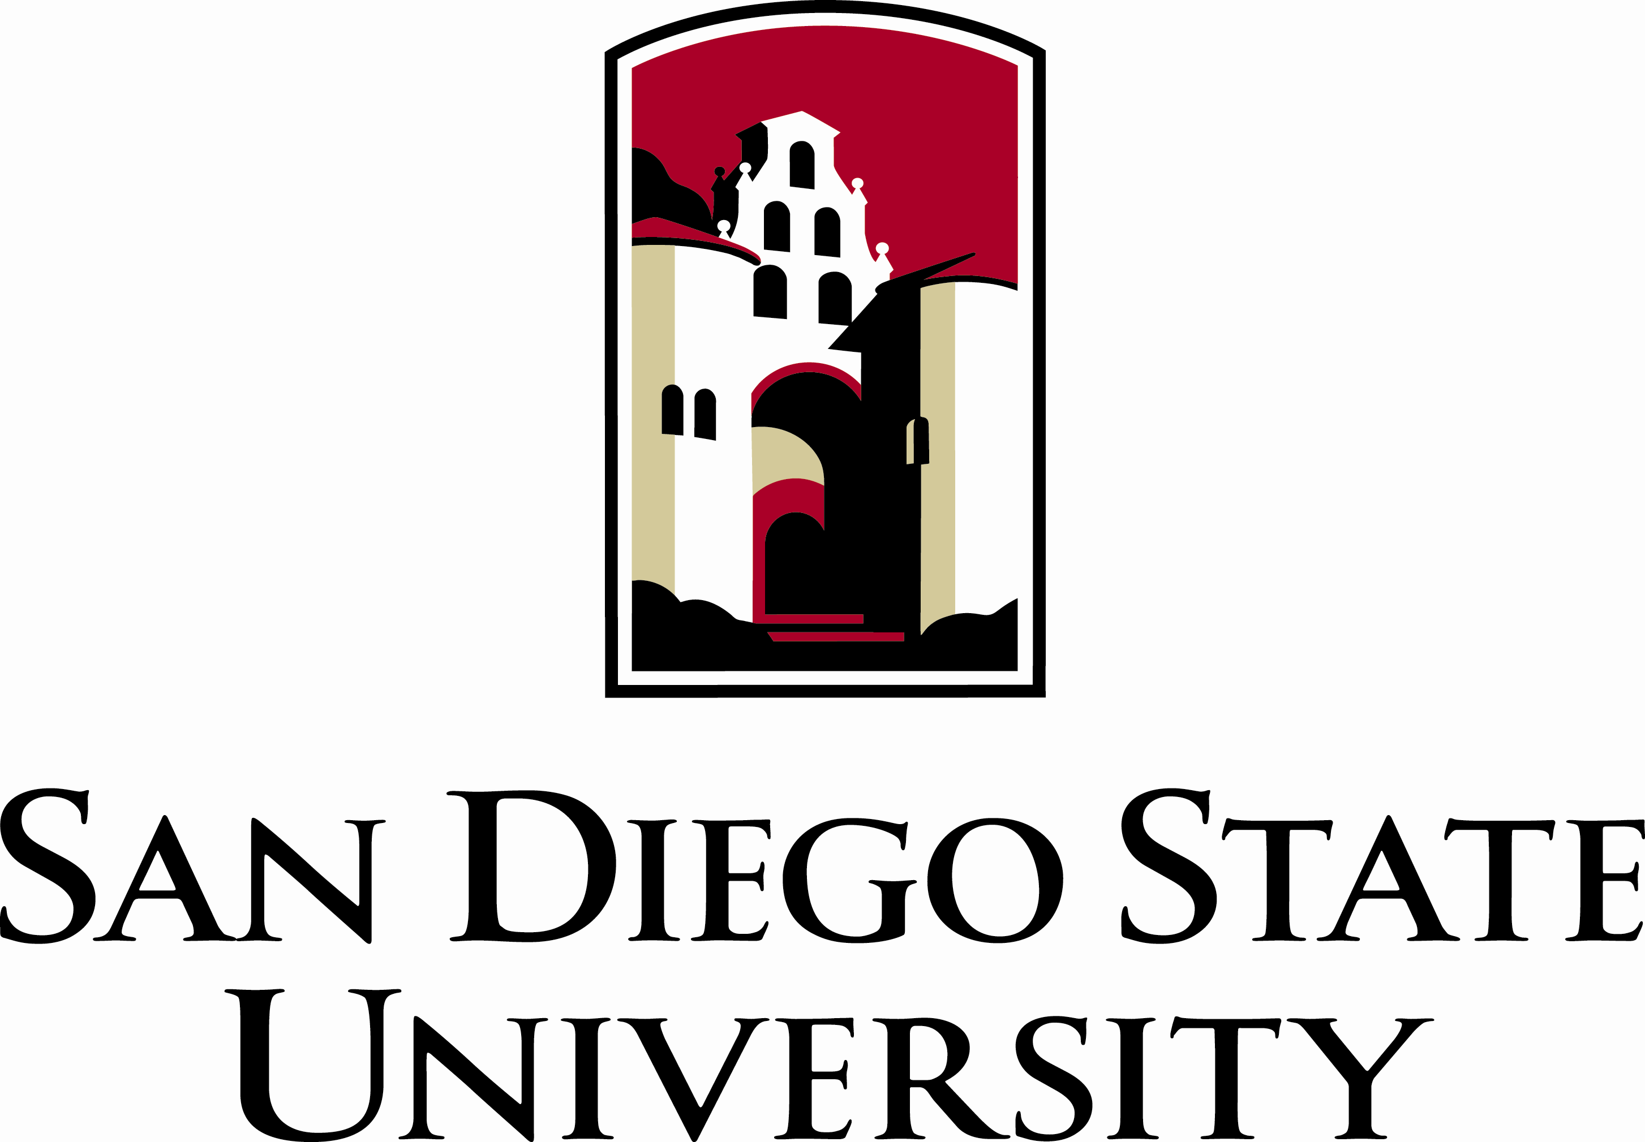

College of Engineering
San Diego State University, Tel: 619-594-6061 Fax: 619-594-6005
5500 Campanile Drive,
San Diego CA 92182-1326 http://www.engineering.sdsu.edu

April 8th 2014 Faculty Meeting

Chaired by Dr. M. Mehrabadi

Faculty present: A. Ashrafi, K. May-Newman, F. Miller, A. Beyene, K. Morsi, L. Demasi, N. Nosseir, Y. Ozturk, S. Sharma, G. Lee, B. Westermo, T. Mitropoulos, S. Bhattacharjee, R. Dowell, B. Narang, M. Gupta, A. E. Engin, f. harris, J. Supernak, M. Sarkar,T. Garcia, M. Pierucci (guest), B. Daly (guest), C. Paolini (guest)

Faculty Absent: R. Kline, K. Walsh, A. Alimohammad, L. Lee, T. Alves, L. Marino, Z. Bayasi, R. Betancourt, , F. Buyuksonmez, S. Nagaraj, T. Garoma, , A. Plotkin, M. Ponce, J. Harris, S. Seshagiri, D. Hayhurst, G. Jacobs, R. Sabzehgar, T. Johnston, S. Kassegne, A. Szeto, R. L. Tummala, J. Kennedy, J. Valdes, S. Venkataraman, P. Kolen, S. Kumar, E. Olevsky,

Faculty Absent (Justified): K. Moon, J. Katz, R. German

DISCUSSION ITEMS:

- Meeting called to order (11:05 AM).

- The Dean announced the new faculty hired in the College of Engineering, Dr. Reza Sabzehgar (ECE), and Brian Daly, the newly appointed Senior Director of Development for CoE.

- Dean Mehrabadi discussed about the Engineering Design Day on May 9th and encouraged faculty to be present. He also mentioned about the Explore SDSU Day and how the event was successful.

- The Dean reported the status on the engineering building renovation: the entrance door is almost done. The parking space on the back of the building will be modified (landscaping to improve appearance and presentation of the building to visitors).

- Faculty inquired about the possibility of using parking permits near the engineering building, especially after business hours and for transportation of equipment by faculty.

- Dean Mehrabadi and the faculty talked about a vision for a new building for the college. Maintaining a high interest on the new building at university level was identified to be one of the key aspects to success. Faculty suggested to reconsider past interesting themes for the building to avoid starting over again the entire discussion.

- Faculty inquired about the Joint Doctoral Program and the twenty-student cap.

- The Dean reported some examples on competitive start up packages to attract new brilliant assistant professors.

- Finally, the Republic of Georgia Program and its impact on the college was presented by the Dean.

Minutes prepared by Dr. Luciano Demasi

