
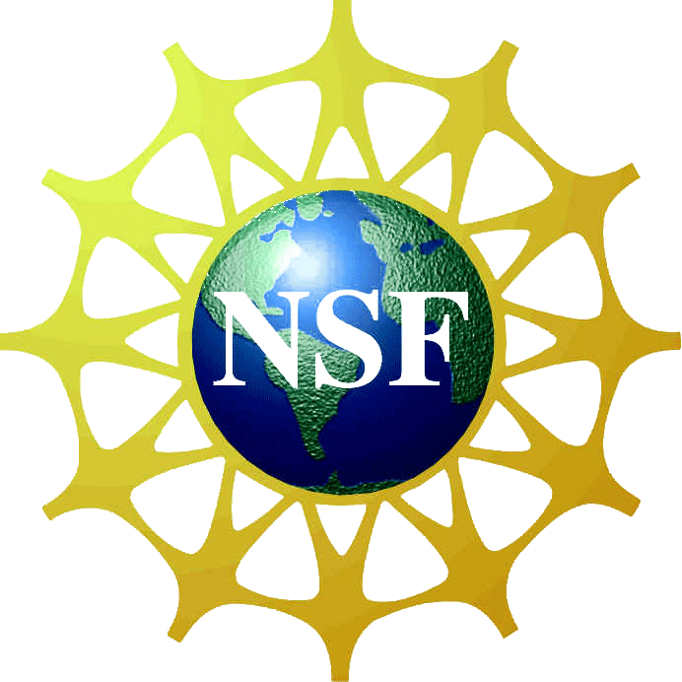
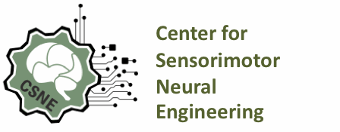
SEMINAR
“Epidural Stimulation Following Spinal Cord Injury to Facilitate Stepping Through Neuromodulation: A Translational Therapeutic Pilot Study”

Donald C. Dunbar, Ph.D.
Professor of Anatomy & Neurobiology
School of Medicine - Medical Sciences Campus
University of Puerto Rico

Tuesday, November 12, 2013
12:00 – 1:00 pm
6495 Alvarado Road, Suite 225
(In-between SDSU campus lot D and Alvarado trolley station)
San Diego, CA 92120
FREE parking and refreshments

Abstract: This seminar will provide an overview of a pilot study conducted in collaboration with the laboratory of Dr. V. Reggie Edgerton (UCLA) to develop a therapy for spinal cord-injured (SCI) patients that is based primarily on electrical stimulation. The study demonstrates that following a partial transverse spinal lesion (hemisection) at a lower thoracic level (T8-T9), the neural circuitry within the lumbar region that controls weight-bearing and stepping remains functional, and can be activated if appropriate sensory (afferent) information from the periphery is provided.

Questions – 619-594-0236 or epamintuan@mail.sdsu.edu

