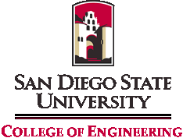

**Informational Faculty Meeting**

Thursday, October 7, 2010, 11:00 am

Engineering – Room 423b

**AGENDA**

1. Introduction of New Development Officer for Engineering, Kori Kaufman
2. Special Achievements
   1. JDP Approval
   2. University of WA/MIT/SDSU Sensorimotor Neural Engineering ERC Proposal

3. Strategic Initiatives – Report Out

1. Define Our Metrics for Differentiating SDSU’s College Of Engineering

D. Hayhurst for R. German

1. Increase Visibility/Develop Marketing Strategy

L. Hinkle, C. McClain

1. Increase Resources (18 months)

L. Tummala

7. New Educational Themes / Distinctions

D. Hayhurst

4. Troops to Engineers (NSF Funded)

1. Academic credit for military training and experience
2. Internships, need coordinator

5. Charges to College Committees

6. Dean’s Remarks

7. General Discussion